BSCS FINAL PROJECT

Lie Detector using facial analysis and physiological signals



Project Advisor

Muhammad Basit Ali Gilani

Presented by:
Group ID: F23CS094

Student Reg# Student Name
L1F20BSCS0114 ABDUL QADEER
L1F20BSCS0660 AREEB HASSAN L1F20BSCS0988 MOHAMMAD ALI

Faculty of Information Technology

University of Central Punjab
Complete System
SDP Phase IV

Lie Detector using facial analysis and physiological signals
Advisor: Muhammad Basit Ali Gilani

Team F23CS094
Member Name | Primary Responsibility
Abdul Qadeer | Project Lead
Areeb Hassan | Review and Validation
Mohammad Ali | Diagram and Technical Visualization

Table of Contents
Table of Contents i
Revision History ii
Abstract iii
1. Introduction iii
1.1 Product iii
1.2 Background iii
1.3 Objective(s)/Aim(s)/Target(s) iii
1.4 Scope iv
1.5 Business Goals iv
1.6 Document Conventions iv
1.7 Miscellaneous iv
2. Technical Architecture 1
2.1 Application and Data Architecture 2
2.2 Component Interactions and Collaborations 2
2.3 Technology Architecture 5
2.4 Architecture Evaluation 5
2.4.1 Reasons for Technology Choices: 5
2.4.2 Pros and Cons: 6
2.4.3 Alternatives Considered: 6
3. Detailed/Component Design 7
3.1 Component-Component Interface 7
3.2 Component-Human Interface 7
4. Screenshots/Prototype 8
4.1 Workflow 8
4.2 Screens 9
5. Test Specification and Results 11
5.1 Test Case Specification 11
5.2 TC-2 12
5.3 TC-3 13
5.4 TC-4 13
5.5 TC-5 14
5.6 TC-6 14
5.7 TC-7 15
5.8 TC-8 15
5.9 TC-9 16
5.10 TC-10 16
5.11 TC-11 17
5.12 TC-12 17
5.13 TC-13 18
5.14 Summary of Test Results 18
6. Project Completion Status 19
7. Deployment/Installation Guide 20
8. User Manual 21
9. References 23
10. Project Summary Form 24
Appendix B: IV & V Report 28

Revision History
Name | Date | Reason For Changes | Version

Abstract
Traditional polygraph tests have long been used to detect deception by measuring physiological responses such as heart rate, respiration, and galvanic skin response. However, these tests require expensive, specialized hardware and trained operators to administer and interpret the results, limiting their accessibility and scalability. Inspired by the polygraph test, we propose a novel, non-intrusive approach to deception detection that relies solely on video input and advanced computer vision techniques.
Our implementation leverages standard video cameras to capture facial expressions, eye movements, and other behavioral indicators, analyzing these cues using OpenCV, Media Pipe, and machine learning models. By monitoring changes in heart rate through facial color analysis, detecting micro-expressions, and assessing other non-verbal behaviors, our system aims to identify potential signs of deception. This method eliminates the need for physical attachments and specialized equipment, offering a more accessible and scalable solution for deception detection.
This innovative approach to deception detection has significant potential applications in security screenings, forensic investigations, and other areas where traditional polygraph tests are used, making the process more accessible and less invasive. By integrating advancements in computer vision and behavioral analysis, our system represents a promising step toward more widely usable and cost-effective deception detection technology.

Introduction
The advancement of technology in the field of deception detection has opened new avenues for research and development, leading to the creation of innovative solutions that transcend traditional methods. This project focuses on developing a software system that employs facial analysis and physiological signal processing to detect deceptive behavior more accurately than existing technologies.

Product
The software being developed is a deception detection system designed to analyze real-time facial expressions and physiological signals to differentiate between truth and deception. This system applies advanced algorithms to video input, capturing subtle physiological and behavioral changes that often accompany deceit. The product is a comprehensive tool that combines research findings and technological advancements to offer a novel solution in the realm of security, psychology, and interrogation techniques.

Background
Deception detection has historically relied on polygraph testing and the subjective judgment of trained professionals. Recent studies, however, have pointed to the potential of facial analysis and physiological responses as more reliable indicators of deceit. Projects such as "Bag-of-lies" and "Deception in the eyes of the deceiver" have laid the groundwork by demonstrating the feasibility of using machine learning and computer vision for this purpose. Unlike these predecessors, our project integrates both facial and physiological signal analyses, providing a multifaceted approach to deception detection that is both innovative and capable of achieving superior accuracy.

Objective(s)/Aim(s)/Target(s)
The primary objective is to develop a deception-detecting tool by integrating facial analysis with physiological signal processing. The system aims to provide a real-time, non-invasive tool that can be utilized in various professional settings, enhancing the ability to discern truth from deception without relying on conventional, often invasive, and expensive, methods.

Scope
This project's scope includes the development of the software tool, its underlying algorithms, and a user-friendly interface that allows for the analysis of video data to detect deception. While focused on law enforcement and security applications, the tool's design will accommodate future expansion to other domains, such as clinical psychology and human resources.

Business Goals
- Enhance the accuracy and reliability of deception detection in critical settings.
- Provide a non-invasive, user-friendly tool for professionals in law enforcement, security, and related fields.
- Establish a foundation for future research and development in the field of deception detection technology.

Document Conventions
This DTS document follows the MLA format guidelines, employing bold-faced text for section headings, italicized text for external system references, and highlighted text to define key terms. These conventions facilitate the clear presentation and organization of the document.

Miscellaneous
The project embraces a collaborative approach, inviting contributions from across the academic and professional spectrum to ensure a comprehensive understanding of the deception detection domain. Emphasis is placed on ethical considerations, with a commitment to respecting privacy and ensuring the responsible use of technology.

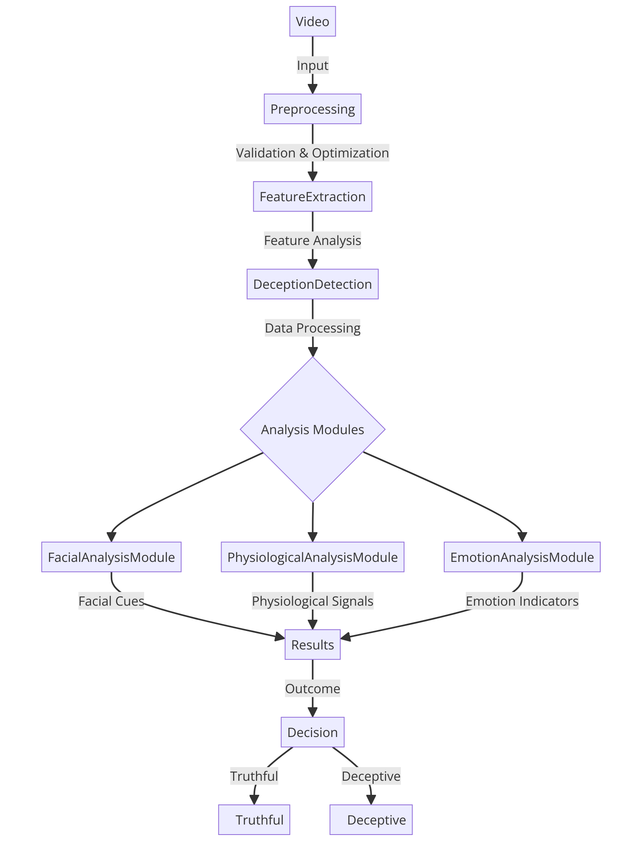
Technical Architecture

Application and Data Architecture
The Deception Detection System offers a streamlined user interface for uploading and validating video data, ensuring compatibility and quality for analysis. After validation, the video undergoes preprocessing to optimize it for feature extraction, using technologies like OpenCV and MediaPipe’s Face Mesh to analyze facial and physiological cues indicative of deception.

Advanced pattern recognition algorithms and machine learning models analyze these cues to detect deception. The results are then presented through an intuitive graphical user interface, providing users with detailed insights to support decision-making in professional settings like interviews and investigations.

This architecture ensures that the system remains efficient and adaptable, capable of handling various video inputs and producing reliable analyses with minimal user effort.

Component Interactions and Collaborations
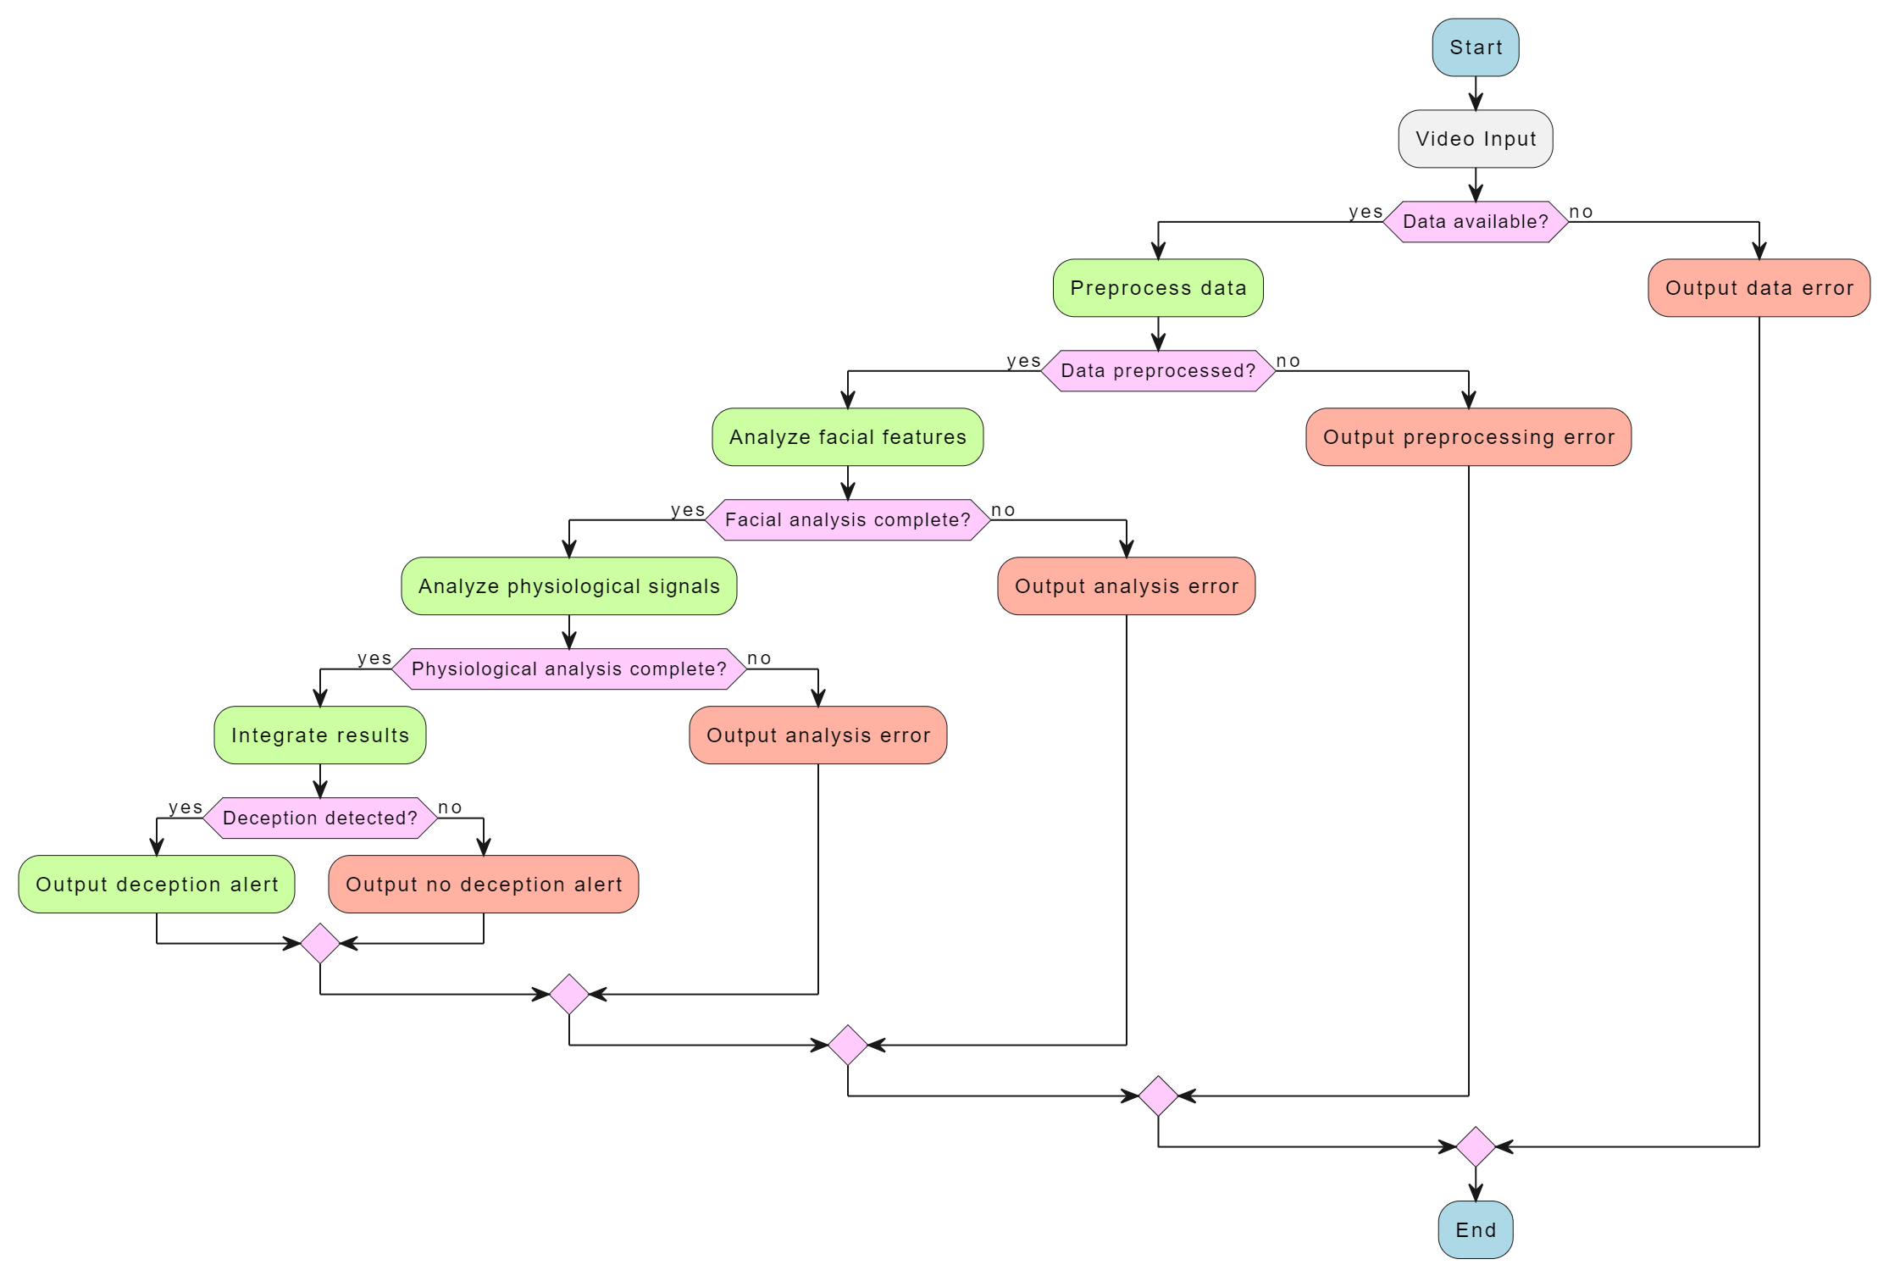
Activity Diagram

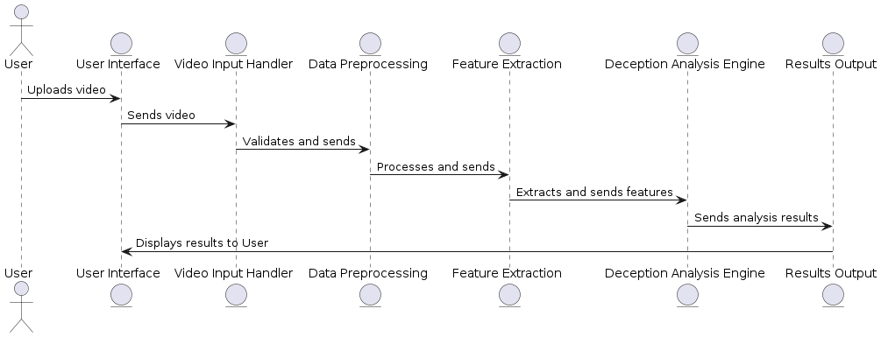
DFD

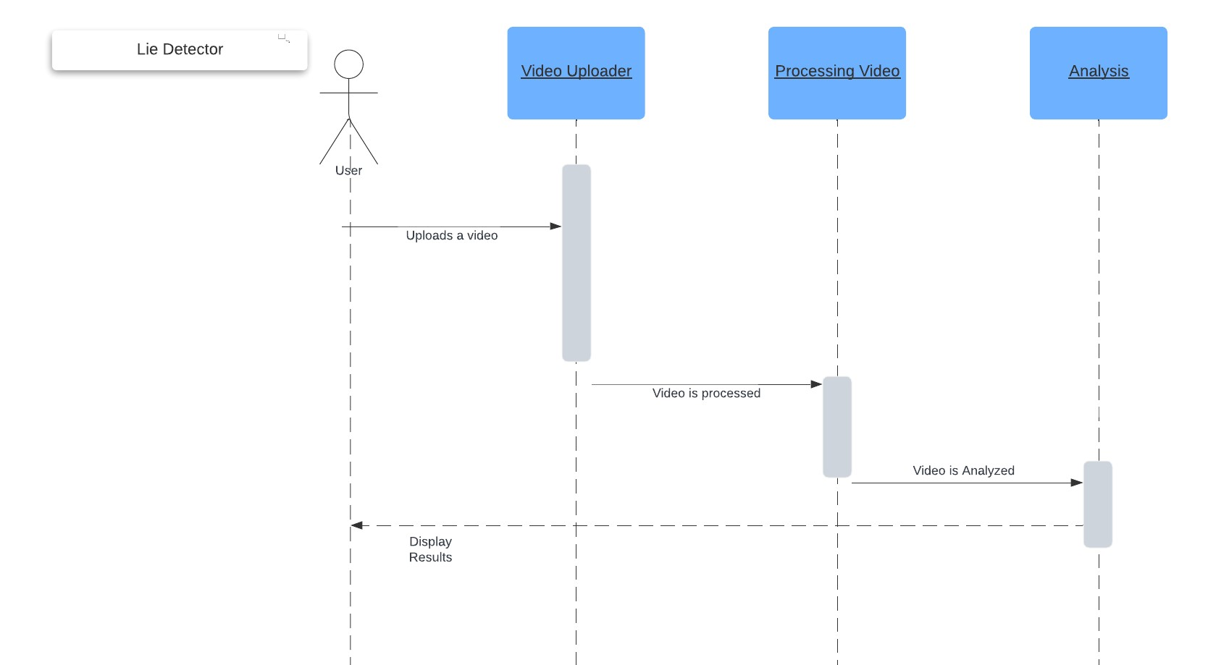
Event Trace

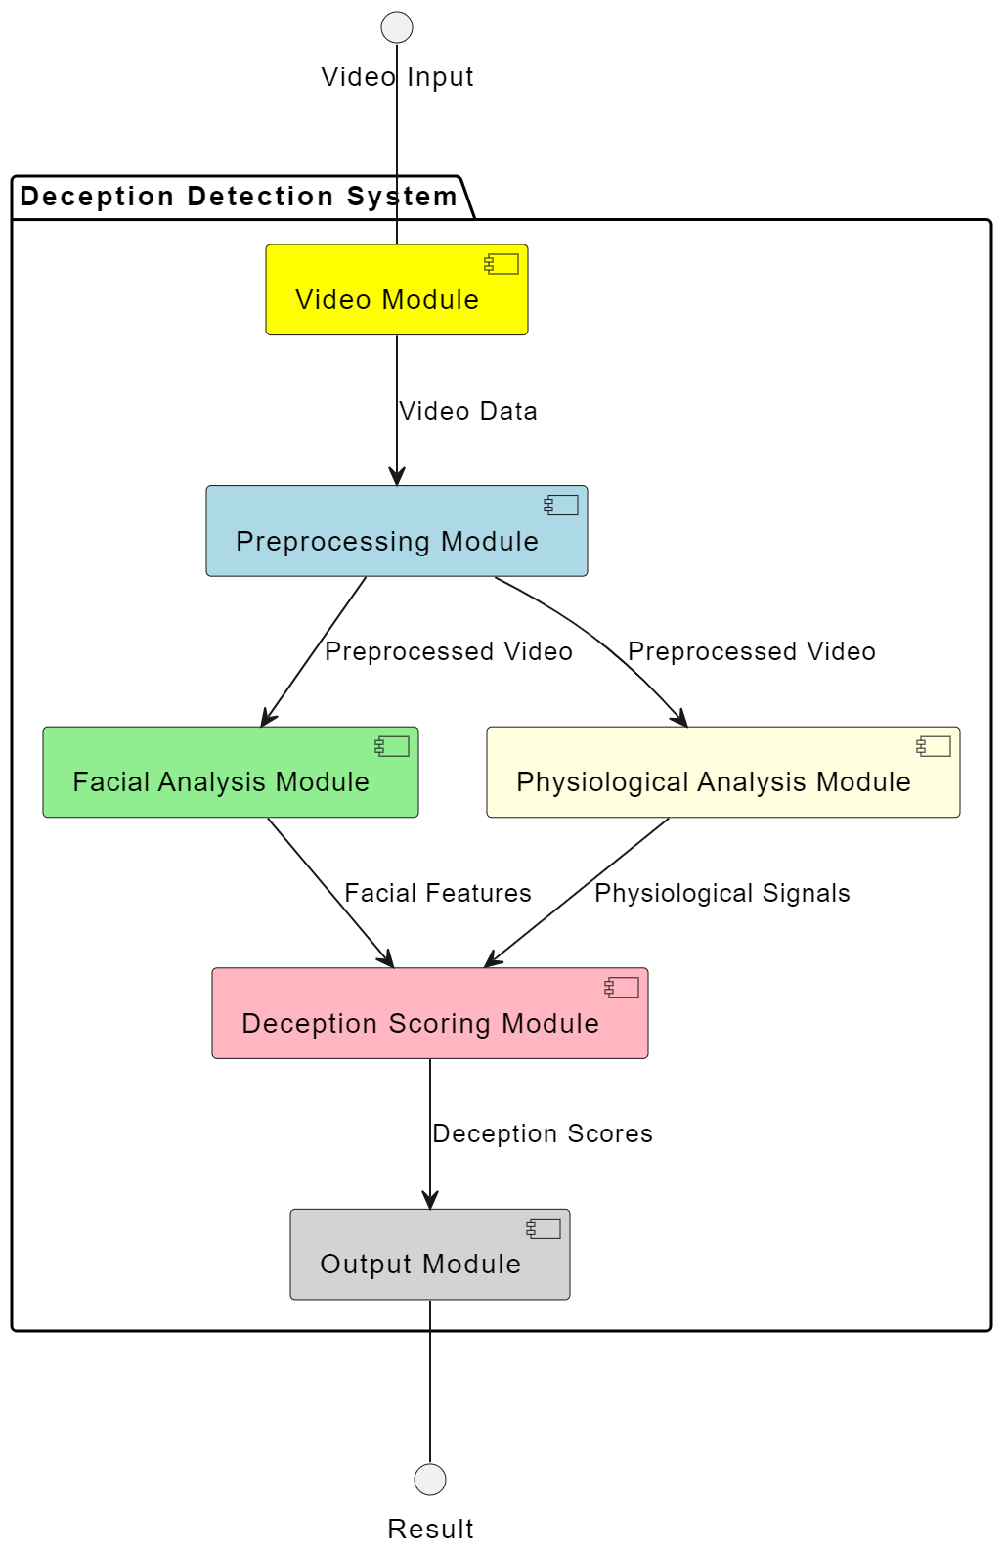
Component Diagram

Technology Architecture
The technology architecture of our system includes a standalone executable (.exe) that runs on Windows, requiring a robust environment with 6-8 GB of RAM and a CPU of at least 3 GHz. This setup supports the application's intensive processing needs for real-time deception detection, ensuring efficient and reliable performance.

Architecture Evaluation
The architecture of our deception detection system leverages Python, Pygame, MediaPipe, OpenCV, and FER (Facial Expression Recognition) to deliver a robust and efficient solution. Here is a detailed evaluation of the selected technologies:

Reasons for Technology Choices:
- Python: Python was chosen for its simplicity and extensive library support. Its robust ecosystem includes powerful libraries for machine learning, image processing, and data analysis, making it ideal for developing complex applications like deception detection.
- Pygame: Pygame was selected for creating the user interface due to its ease of use and flexibility in handling real-time interactive applications. It allows for rapid development and customization of the user interface, which is crucial for a responsive and engaging user experience.
- MediaPipe: MediaPipe was chosen for its advanced machine learning models and capabilities in facial and hand landmark detection. It provides efficient and accurate tracking of facial expressions and movements, which are essential for detecting deceptive behavior.
- OpenCV: OpenCV was selected for its comprehensive suite of computer vision tools. It excels in image processing tasks, such as frame extraction, color analysis, and feature detection, all of which are critical for analyzing video data in real-time.
- FER (Facial Expression Recognition): FER was integrated to analyze facial expressions and emotions from video data. It provides additional insights into the subject's emotional state, which can be a significant indicator of deceptive behavior.
- Windows Platform: The application is deployed on Windows to leverage its widespread use in professional environments, ensuring broad accessibility and compatibility. The system requires a robust setup with 6-8 GB of RAM and a CPU of at least 3 GHz to handle intensive processing tasks efficiently.

Pros and Cons:
- Pros:
  - Python: Streamlines development with its extensive libraries and ease of use. Enables rapid prototyping and integration with machine learning models.
  - Pygame: Facilitates the creation of interactive and visually appealing user interfaces.
  - MediaPipe: Offers state-of-the-art machine learning models for accurate and efficient facial and hand landmark detection.
  - OpenCV: Provides powerful tools for image and video processing, essential for real-time analysis.
  - FER: Enhances the system’s capability by analyzing facial expressions to detect emotional states related to deception.
  - Windows Platform: Ensures compatibility with most enterprise environments and user setups.
- Cons:
  - Python: May not match the performance of lower-level languages like C++ in processing-intensive tasks.
  - Pygame: Primarily designed for games, it might not scale as well for more complex or data-intensive applications.
  - MediaPipe: While highly effective, its integration requires careful management of dependencies and computational resources.
  - OpenCV: Can be complex to optimize for performance in real-time applications.
  - FER: Depends on the quality of video input; low-resolution or poor-quality videos might affect accuracy.
  - Windows Platform: Restricts the application to Windows users, potentially limiting accessibility to those on other operating systems.

Alternatives Considered:
- Alternative Programming Languages (e.g., C++, Java): Considered for performance advantages but were outweighed by Python's ease of development and extensive library support.
- Other UI Frameworks (e.g., QT, Electron): Considered for more sophisticated interfaces and cross-platform capabilities but Pygame was chosen for its simplicity and real-time capabilities.
- Alternative Platforms (e.g., macOS, Linux): While expanding to other operating systems could increase accessibility, the initial focus on Windows allows for a streamlined development process and faster deployment.

Detailed/Component Design

Component-Component Interface
The components of the Deception Detection System interact to process video inputs, analyze them for deception indicators, and display results to the user. The sequence diagram illustrates the flow of data and the interactions between these components.

Sequence Diagram Explanation:
- User Interface (UI): The entry point for users to upload videos and view results.
- Video Input Handler: Validates and forwards the video to the preprocessing module.
- Data Preprocessing: Standardizes the video for analysis.
- Feature Extraction: Extracts facial and physiological features from the preprocessed video.
- Deception Analysis Engine: Analyzes the extracted features to detect deception.
- Results Output: Displays the analyzed results to the user.
Each component communicates through well-defined interfaces, ensuring modularity and ease of maintenance.

Component-Human Interface
- Main Screen:
  - Components:
    - Webcam button: Allows users to select the webcam as the video input source.
    - Video File button: Enables users to upload a video file for analysis.
    - Draw Landmarks checkbox: An option for users to toggle the drawing of facial landmarks on the video.
    - Exit button: Closes the application.
  - Description: This screen is the entry point for users, providing options to choose the video input source and other settings.
- Video Playback Screen:
  - Components:
    - Exit button: Exits the video playback and analysis screen.
    - Play button: Starts playing the video.
    - Pause button: Pauses the video playback.
    - Stop button: Stops the video playback.
    - Recalibrate button: Recalibrates the analysis based on new data.
    - FPS display: Shows the current frames per second of the video playback.
    - Analysis results: Displays real-time analysis results such as BPM, heart rate changes, lip compression, and gaze changes.
  - Description: This screen allows users to interact with the video playback, view real-time analysis results, and control the video playback.
- HCI Norms Followed
- Consistency:
  - Consistent layout and design across all screens to avoid confusion.
  - Uniform button styles and placements for similar functions to ensure intuitive navigation.
- Feedback:
  - Immediate visual feedback when buttons are pressed (e.g., buttons highlight when clicked).
  - Real-time display of analysis results to keep users informed about the system's processing status.
- Simplicity:
  - Minimalist design to keep the interface uncluttered and user-friendly.
  - Only essential options and information are displayed to avoid overwhelming the user.
- Accessibility:
  - Clear and legible fonts and high-contrast colors to ensure readability.
  - Simple and straightforward navigation to cater to users with varying levels of technical expertise.
- Error Prevention and Recovery:
  - Options to recalibrate the system and stop video playback to allow users to correct any mistakes easily.
  - Clear labeling of buttons to prevent accidental actions.

Screenshots/Prototype

Workflow
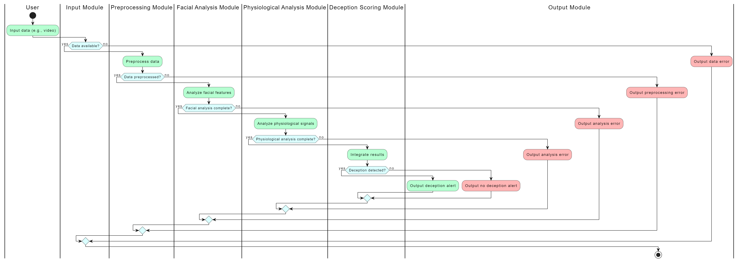
Swimlane Diagram

Screens
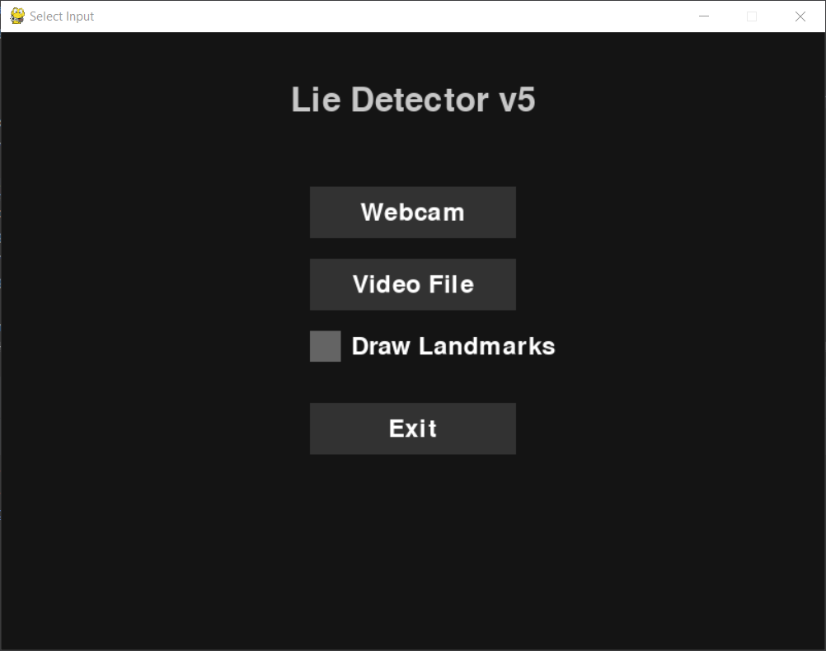
Main Window

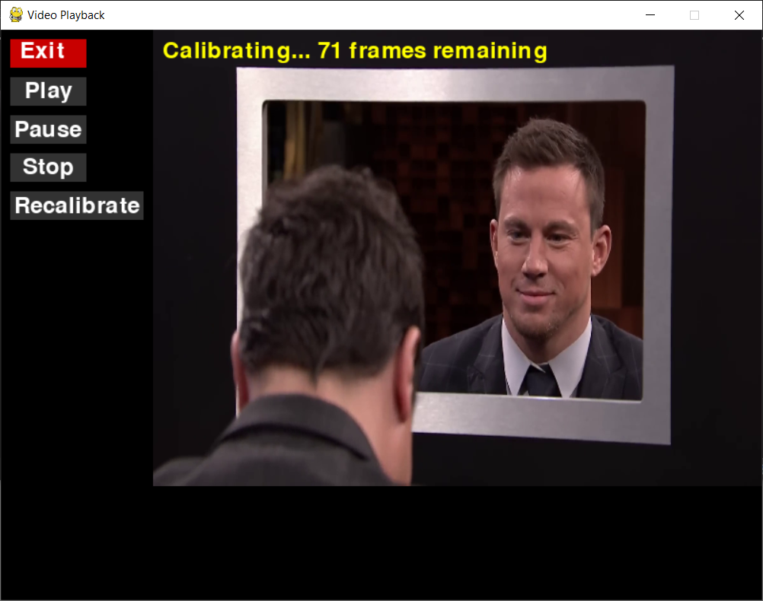
Calibration UI

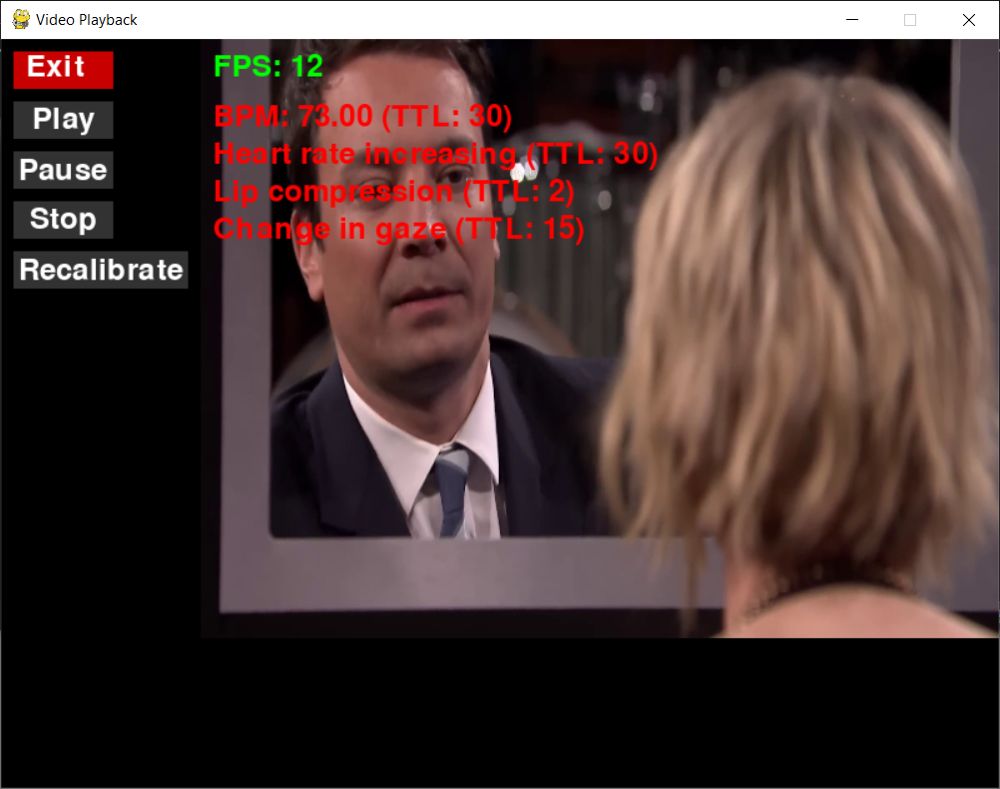
Video Playback and deception detection analysis UI

Test Specification and Results

Test Case Specification
Table 5.1: TC-1
Identifier | TC-1
Related requirements(s) | Use-case ID: UC-1, SRS section: 3.1.1
Short description | Verify the system's ability to accurately detect deception using video input under controlled conditions.
Pre-condition(s) | The system is installed and operational, with a compatible video file ready for analysis.
Input data | Video file of a subject answering questions, where ground truth about truthfulness/deceptiveness is known.
Detailed steps | 1. Launch the application.  2. Upload the video file.  3. Start the analysis.
Expected result(s) | The system should correctly identify the signals of facial and physiological signals
Post-condition(s) | Analysis results are saved and displayed, system remains ready for new input.
Actual result(s) | Pass
Test Case Result | Pass

TC-2
Identifier | TC-2
Related requirements(s) | Use-case ID: UC-2, SRS section: 3.1.2
Short description | Test the system’s performance with varying video quality.
Pre-condition(s) | System is installed and operational, with video files of different resolutions ready for analysis.
Input data | Video files with varying resolutions (e.g., 720p, 480p, 1080p).
Detailed steps | 1. Launch the application.  2. Upload the first video file.  3. Start the analysis.
Expected result(s) | The system should provide consistent and accurate results regardless of video resolution, though lower quality may slightly affect accuracy.
Post-condition(s) | Analysis results are saved and displayed, system remains ready for new input.
Actual result(s) | Pass
Test Case Result | Pass

TC-3
Identifier | TC-3
Related requirements(s) | Use-case ID: UC-3 SRS section: 3.1.3
Short description | Verify the system's ability to detect deception in low light conditions.
Pre-condition(s) | The system is installed and operational with a low light video file ready for analysis.
Input data | Video file of a subject answering questions recorded in low light conditions.
Detailed steps | 1. Launch the application  2. Upload the low light video file.  3. Start the analysis.
Expected result(s) | The system should fail to accurately identify the facial and physiological signals due to poor lighting conditions and return a "fail" result.
Post-condition(s) | Analysis results indicate failure due to insufficient lighting, and the system remains ready for new input.
Actual result(s) | Fail
Test Case Result | Fail

TC-4
Identifier | TC-4
Related requirements(s) | Use-case ID: UC-1, SRS section: 2.1.1
Short description | Test the video upload functionality for various formats and sizes.
Pre-condition(s) | System is installed and operational, with video files of different formats and sizes ready for upload.
Input data | Video files in formats such as .mp4, .avi, .mov, and sizes ranging from 1MB to 500MB.
Detailed steps | 1. Launch the application.  2. Select the video file to upload.  3. Click on the 'Upload' button.  4. Repeat for each video file.
Expected result(s) | The system should successfully upload video files of all tested formats and sizes without errors.
Post-condition(s) | Uploaded video files are ready for preprocessing, and the system remains ready for new uploads.
Actual result(s) | Pass
Test Case Result | Pass

TC-5
Identifier | TC-5
Related requirements(s) | Use-case ID: UC-2, SRS section: 3.1.2
Short description | Test the system’s handling of different video formats during preprocessing.
Pre-condition(s) | System is installed and operational, with video files in various formats ready for preprocessing.
Input data | Video files in formats such as .mp4, .avi, .mov.
Detailed steps | 1. Launch the application  2. Upload a video file.  3. Start preprocessing  4. Repeat for each video format.
Expected result(s) | The system should successfully preprocess video files of all tested formats without errors.
Post-condition(s) | Preprocessed video files are ready for feature extraction, and the system remains ready for new inputs.
Actual result(s) | Pass
Test Case Result | Pass

TC-6
Identifier | TC-6
Related requirements(s) | Use-case ID: UC-2, SRS section: 3.1.2
Short description | Test the system’s performance with varying video resolutions.
Pre-condition(s) | System is installed and operational, with video files of different resolutions ready for preprocessing.
Input data | Video files with varying resolutions (e.g., 720p, 480p, 1080p).
Detailed steps | 1. Launch the application.  2. Upload a video file.  3. Start preprocessing.  4. Repeat for each video resolution.
Expected result(s) | The system should preprocess video files of all resolutions consistently, though lower quality may slightly affect accuracy.
Post-condition(s) | Preprocessed video files are ready for feature extraction, and the system remains ready for new inputs.
Actual result(s) | Pass
Test Case Result | Pass

TC-7
Identifier | TC-7
Related requirements(s) | Use-case ID: UC-4, SRS section: 3.2.1
Short description | Test the feature extraction from different facial expressions and angles.
Pre-condition(s) | System is installed and operational, with video files showing various facial expressions and angles.
Input data | Video files with different facial expressions (e.g., smiling, frowning, neutral) and angles (e.g., front, side).
Detailed steps | 1. Launch the application.  2. Upload the video file.  3. Start the analysis.  4. Observe and record the features extracted.  5. Repeat for each video file.
Expected result(s) | The system should accurately extract facial features regardless of expressions and angles.
Post-condition(s) | Extracted features are processed and ready for analysis, system remains ready for new input.
Actual result(s) | Pass
Test Case Result | Pass

TC-8
Identifier | TC-8
Related requirements(s) | Use-case ID: UC-5, SRS section: 3.2.2
Short description | Test the accuracy of physiological signal extraction under different lighting conditions.
Pre-condition(s) | System is installed and operational, with video files recorded under various lighting conditions.
Input data | Video files with good, poor, and variable lighting conditions.
Detailed steps | 1. Launch the application.  2. Upload the video file.  3. Start the analysis.  4. Record the accuracy of physiological signal extraction.  5. Repeat for each video file.
Expected result(s) | The system should accurately extract physiological signals regardless of lighting conditions, though poor lighting may slightly affect accuracy.
Post-condition(s) | Extracted signals are processed and ready for analysis, system remains ready for new input.
Actual result(s) | Pass
Test Case Result | Pass

TC-9
Identifier | TC-9
Related requirements(s) | Use-case ID: UC-6, SRS section: 3.3.1
Short description | Test the analysis engine with known deceptive and non-deceptive behaviors.
Pre-condition(s) | System is installed and operational, with video files of known deceptive and non-deceptive behaviors.
Input data | Video files labeled as deceptive and non-deceptive.
Detailed steps | 1. Launch the application.  2. Upload a deceptive behavior video file.  3. Start the analysis.  4. Record the results.  5. Repeat for non-deceptive behavior video files.  6. Compare the results with expected behaviors.
Expected result(s) | The system should correctly identify deceptive and non-deceptive behaviors.
Post-condition(s) | Analysis results are accurate and saved, system remains ready for new input.
Actual result(s) | Pass
Test Case Result | Pass

TC-10
Identifier | TC-10
Related requirements(s) | Use-case ID: UC-7, SRS section: 3.3.2
Short description | Test the system’s response to edge cases, such as very short or very long videos.
Pre-condition(s) | System is installed and operational, with edge case video files ready for analysis.
Input data | Video files shorter than 10 seconds and longer than 30 minutes.
Detailed steps | 1. Launch the application.  2. Upload the video file.  3. Start the analysis.  4. Record the system’s response time and accuracy.  5. Repeat for each edge case video file.
Expected result(s) | The system should handle edge cases without crashing and provide reasonable analysis results.
Post-condition(s) | System remains stable and ready for new inputs.
Actual result(s) | Pass
Test Case Result | Pass

TC-11
Identifier | TC-11
Related requirements(s) | Use-case ID: UC-9, SRS section: 3.4.2
Short description | Test the system’s resource usage efficiency.
Pre-condition(s) | System is installed and operational, with monitoring tools available to track resource usage.
Input data | A standard set of video files for analysis.
Detailed steps | 1. Launch the application.  2. Upload a video file.  3. Start the analysis.  4. Monitor CPU, memory, and disk usage during analysis.  5. Repeat for each video file.
Expected result(s) | The system should optimize resource usage, maintaining low CPU and memory usage while processing efficiently.
Post-condition(s) | System resources are efficiently utilized, ready for new inputs.
Actual result(s) | Pass
Test Case Result | Pass

TC-12
Identifier | TC-12
Related requirements(s) | Use-case ID: UC-10, SRS section: 3.5.1
Short description | Test the system's ability to handle audio input and synchronize it with video for analysis.
Pre-condition(s) | System is installed and operational, with video files containing audio tracks ready for analysis.
Input data | Video files with clear and distinct audio tracks.
Detailed steps | 1. Launch the application.  2. Upload the video file with audio.  3. Start the analysis.  4. Observe and record if audio is synchronized and used in the analysis.  5. Repeat for each video file.
Expected result(s) | The system should successfully process the audio track, synchronize it with the video, and use it in the analysis.
Post-condition(s) | Audio and video are synchronized, and analysis is complete. The system remains ready for new inputs.
Actual result(s) | Pass
Test Case Result | Pass

TC-13
Identifier | TC-13
Related requirements(s) | Use-case ID: UC-12, SRS section: 3.5.3
Short description | Test the system’s performance with varying audio quality.
Pre-condition(s) | System is installed and operational, with video files containing audio of different quality levels ready for analysis.
Input data | Video files with high, medium, and low audio quality.
Detailed steps | 1. Launch the application.  2. Upload the video file with varying audio quality.  3. Start the analysis.  4. Observe and record the system's performance and accuracy with different audio quality levels.  5. Repeat for each video file.
Expected result(s) | The system should provide consistent and accurate audio analysis regardless of audio quality, though lower quality may slightly affect accuracy.
Post-condition(s) | Analysis results are saved, and the system remains ready for new inputs.
Actual result(s) | Pass
Test Case Result | Pass

Summary of Test Results
Table 6.2: Summary of Test Results
Module Name | Test cases run | Number of defects found | Number of defects corrected so far | Number of defects still need to be corrected
Video Upload Module | TC-4 | 1 | 1 | 0
Data Preprocessing Module | TC-1, TC-2, TC-5, TC-6 | 2 | 2 | 0
Feature Extraction Module | TC-7, TC-8 | 2 | 1 | 1
Deception Analysis Engine | TC-9, TC-10 | 1 | 1 | 0
User Interface | TC-1, TC-2, TC-3, TC-4 | 1 | 1 | 0
Performance Optimization | TC-11 | 1 | 0 | 1
Audio Module | TC-12, TC-13 | 2 | 1 | 1
Complete System | Sum of all above | 10 | 7 | 3

Project Completion Status
Table 7.1: Project Completion Status
Module Name | Status  (Complete, Partially Implemented, Not Implemented)
Video Upload Module | Complete
Data Preprocessing Module | Complete
Feature Extraction Module | Complete
Deception Analysis Engine | Complete
User Interface | Complete
Performance Optimization | Complete
Audio Module | Complete
Complete System | Completed

Table 7.2: Objective(s)/Target(s) Status
Target/Objective | Status  (Completed,  Partially Completed,  Not Completed) | Reason(s)
Develop Deception-Detection Tool | Completed | Full functionality implemented and tested successfully
Integrate Facial Analysis | Completed | Successfully integrated facial analysis using OpenCV and MediaPipe
Physiological Signal Processing | Completed | Signal processing fully implemented  And optimized
Real-time Analysis Capability | Completed | Real-time analysis achieved with optimized performance
Non-Invasive Tool for Professional Use | Completed | Tool is functional, user-friendly, and tested for reliability and accuracy
Number of Targets Completed | 5
Number of Targets Partially Completed | 0
Number of Targets Not Completed | 0

Deployment/Installation Guide
This guide provides detailed instructions for deploying and installing the Lie Detector system using facial analysis and physiological signals as a Windows executable (.exe) file.
- System Requirements
- Operating System: Windows 10 or later
- RAM: 6-8 GB minimum
- CPU: Minimum 3 GHz
- Storage: At least 2 GB of free disk space

Pre-Installation Steps:
- Download the .exe File:
  - Obtain the .exe file for the Lie Detector system from the provided link or shared drive.

Installation Steps:
- Run the Installer:
  - Locate the downloaded .exe file on your system.
  - Double-click the .exe file to start the installation process.
- Follow the Installation Wizard:
  - Follow the prompts in the installation wizard to install the Lie Detector system.
  - Choose the installation directory (default is usually recommended).
  - Complete the installation by clicking "Finish" once the installation is done.

Running the Application:
- Launch the Application:
  - Navigate to the directory where the application was installed.
  - Double-click the application icon (LieDetector.exe) to launch the Lie Detector system.
- Using the Application:
  - Main Screen:
    - Click on the Webcam button to select the webcam as the video input source.
    - Click on the Video File button to upload a video file for analysis.
    - Optionally, check the Draw Landmarks checkbox to toggle the drawing of facial landmarks on the video.
    - Click on the Exit button to close the application.
  - Video Playback Screen:
    - Use the Play, Pause, and Stop buttons to control video playback.
    - Click on the Recalibrate button to recalibrate the analysis based on new data.
    - View the FPS display to see the current frames per second of the video playback.
    - The Analysis results section displays analysis results such as BPM heart rate changes, lip compression, and gaze changes.
    - Click on the Exit button to return to the main screen.

Troubleshooting:
- Permission Issues:
  - If you encounter permission issues, run the installer and the application as an administrator.
- Application Crashes:
  - Ensure your system meets the minimum hardware requirements. Insufficient RAM or CPU speed may cause the application to crash.
- Missing DLL Files:
  - If the application fails to start due to missing DLL files, ensure that all required dependencies are installed. You may need to install Visual C++ Redistributable Packages for Visual Studio.

User Manual
This user manual provides instructions on how to use the Lie Detector system after installation.
- Main Screen
- Webcam Input:
  - Click the Webcam button to select the webcam as the video input source.
  - Ensure your webcam is properly connected and functioning.
- Video File Input:
  - Click the Video File button to upload a video file for analysis.
  - Select the video file from your system and click Open.
- Draw Landmarks (Optional):
  - Check the Draw Landmarks checkbox to toggle the drawing of facial landmarks on the video. This feature helps visualize the analysis points on the face.
- Exit:
  - Click the Exit button to close the application.
- Video Playback Screen
- Play:
  - Click the Play button to start video playback.
- Pause:
  - Click the Pause button to pause the video playback.
- Stop:
  - Click the Stop button to reset the video playback.
- Recalibrate:
  - Click the Recalibrate button to recalibrate the analysis based on new data. This is useful if you want to reset the analysis parameters for a new session.
- FPS Display:
  - View the FPS (Frames Per Second) display to see the current frames per second of the video playback. This helps in monitoring the performance of the system.
- Analysis Results:
  - The Analysis results section displays analysis results, including:
    - BPM (Heart Rate): Shows changes in heart rate detected through facial color analysis.
    - Lip Compression: Indicates instances of lip compression, a potential sign of deception.
    - Gaze Changes: Tracks changes in gaze direction, which can be an indicator of deceptive behavior.
- Exit:
  - Click the Exit button to return to the main screen.
- Troubleshooting
- Webcam Issues:
  - Ensure your webcam is properly connected and not being used by another application.
  - Restart the application if the webcam feed does not appear.
- Video Playback Issues:
  - Ensure the video file format is supported by the application. Commonly supported formats include MP4, AVI, and MKV.
  - Check your system's performance if the video playback is lagging.
- Analysis Accuracy:
  - Ensure good lighting conditions for the webcam input to improve the accuracy of facial analysis.
  - Make sure the subject's face is clearly visible and unobstructed during video recording.

References
- Gupta, Viresh, et al. "Bag-of-lies: A multimodal dataset for deception detection." Proceedings of the IEEE/CVF Conference on Computer Vision and Pattern Recognition Workshops, 2019, https://ieeexplore.ieee.org/document/9025340.
- Khan, Wasiq, et al. "Deception in the eyes of deceiver: A computer vision and machine learning based automated deception detection." Expert Systems with Applications, vol. 169, 2021, p. 114341, https://doi.org/10.1016/j.eswa.2020.114341.
- Stathopoulos, Anastasis, et al. "Deception detection in videos using robust facial features." Proceedings of the Future Technologies Conference (FTC) 2020, Volume 3. Springer International Publishing, 2021, https://doi.org/10.1007/978-3-030-63092-8_45.
- Speth, Jeremy, et al. "Deception detection and remote physiological monitoring: A dataset and baseline experimental results." 2021 IEEE International Joint Conference on Biometrics (IJCB). IEEE, 2021, https://ieeexplore.ieee.org/document/9484409.
- Lloyd, E.P., Deska, J.C., Hugenberg, K. et al. Miami University deception detection database. Behav Res 51, 429–439 (2019). https://doi.org/10.3758/s13428-018-1061-4
- Vukovic, B. (2024). Verbal, Nonverbal, and Physiological Cues to Deception. Retrieved from https://purl.lib.fsu.edu/diginole/honors_thesis_submission-94af24f3-b51d-4309-8a07-cd1f49e38847

Project Summary Form
Name of Project | Lie Detector using Facial Analysis and Physiological Signals
Project Type | Traditional Project
Department | Faculty of Information Technology
Start Date | 01/10/23
Completion Date | 30/05/24
Supervisor / Team Leader | Muhammad Basit Ali Gilani
Team Members (if any) | Abdul Qadeer, Areeb Hassan, Mohammad Ali
Funding Agency (if any) | N. A
Amount of Funding (if any) | N. A
Assign SDGs to Project | 1. SDG 3: Good Health and Well-being  - Target 3.4: By enhancing the detection of deception, this project can contribute to reducing violence and injuries by providing a tool that can be used in security and forensic investigations. This can indirectly contribute to promoting mental health and well-being by reducing the psychological impact of false accusations and improving the reliability of security measures.  - 2. SDG 9: Industry, Innovation, and Infrastructure  - Target 9.5: The project promotes innovation by developing an advanced, non-intrusive deception detection system using cutting-edge computer vision and machine learning techniques. It supports scientific research and technological advancements, which are crucial for building resilient infrastructure and fostering innovation.  - 3. SDG 16: Peace, Justice, and Strong Institutions  - Target 16.3: By providing a reliable tool for detecting deception, this project supports the promotion of the rule of law at national and international levels and ensures equal access to justice for all. It can enhance the effectiveness of security screenings, forensic investigations, and other applications where truth verification is critical.  - 4. SDG 4: Quality Education  - Target 4.7: The development and deployment of this project contributes to quality education by serving as a practical example of the application of computer science and technology in solving real-world problems. It can be used as a learning tool for students and researchers in related fields, promoting technical education and skills development.
Motivation of Project | Traditional polygraph tests have limitations, including the need for expensive hardware and is intrusive in nature, making them less accessible and scalable for widespread use.This project aims to develop a non-intrusive method for deception detection using video input and computer vision techniques, offering a more accessible and scalable solution compared to traditional polygraph tests.
Practical / Potential Application | Security screenings, forensic investigations, professional settings
Abstract | Classic polygraph tests use several physiological signals such as heart rate, respiration, and galvanic skin response to detect deception. However, these tests require expensive and specifically designed hardware, as well as trained professionals to operate them properly. Such limitations significantly restrict the usage of polygraph tests. While we take inspiration from the polygraph test, our approach is novel and non-intrusive, using video as the only input.  Our system employs OpenCV, Google’s Media Pipe, and machine learning models to analyze facial color, gaze, and other physiological signals indicating changes. This avoids the need for uncomfortable attachments. Like a polygraph test, our tool requires human context and professional interpretation for accurate analysis.  A user-friendly interface has been created for professionals to easily interact with our system and view the analysis and detected changes. The system mainly focuses on key physiological signals, including blink rate, gaze direction, and lip compression, comparing them with an individual’s baseline in real-time. The outcome will be a user-friendly computer application that analyzes non-verbal universal signals of lying to improve professional decision-making.  The intersections of knowledge and advancements in computer vision and behavioral analysis fields allow for detecting deception by comparing an individual’s signals with their baseline. The main advantage of the described system is its accessibility, as it does not use specific hardware or wearable attachments and only requires video input. This provides new avenues for deception detection in a wide range of applications, such as security screenings
Key Technical Features | Real-time facial and physiological analysis, Machine learning integration, User-friendly interface
Projects Images / Screenshots | 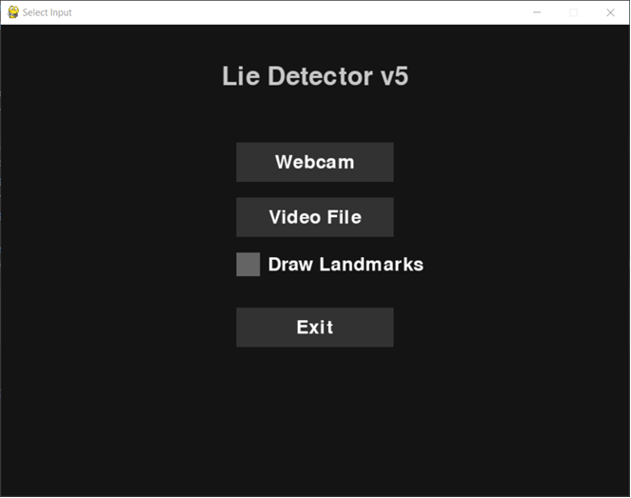  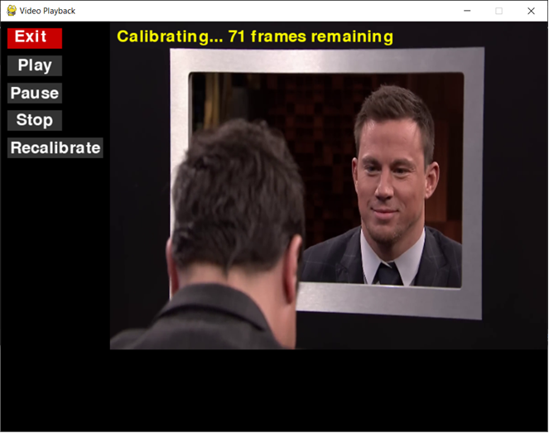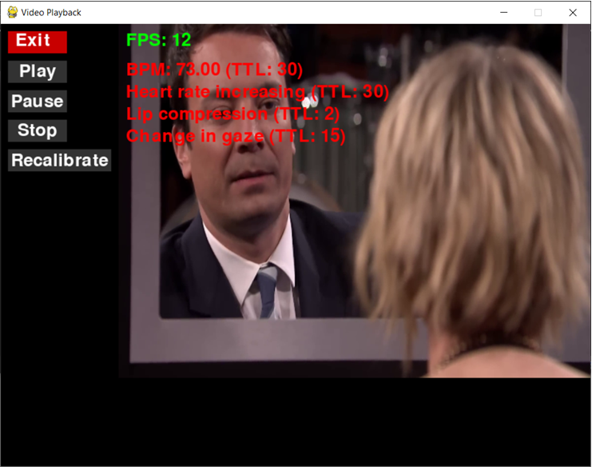

Appendix B: IV & V Report
(Independent verification & validation)
IV & V Resource

Name Signature

S# | Defect Description | Origin Stage | Status | Fix Time
 |  |  |  | Hours | Minutes
1
2
3
…
Table B.1: List of non-trivial defects

This document has been adapted from the following:
- Previous project templates at UCP
- High-level Technical Design, Centers for Medicare & Medicaid Services. (www.cms.gov)

